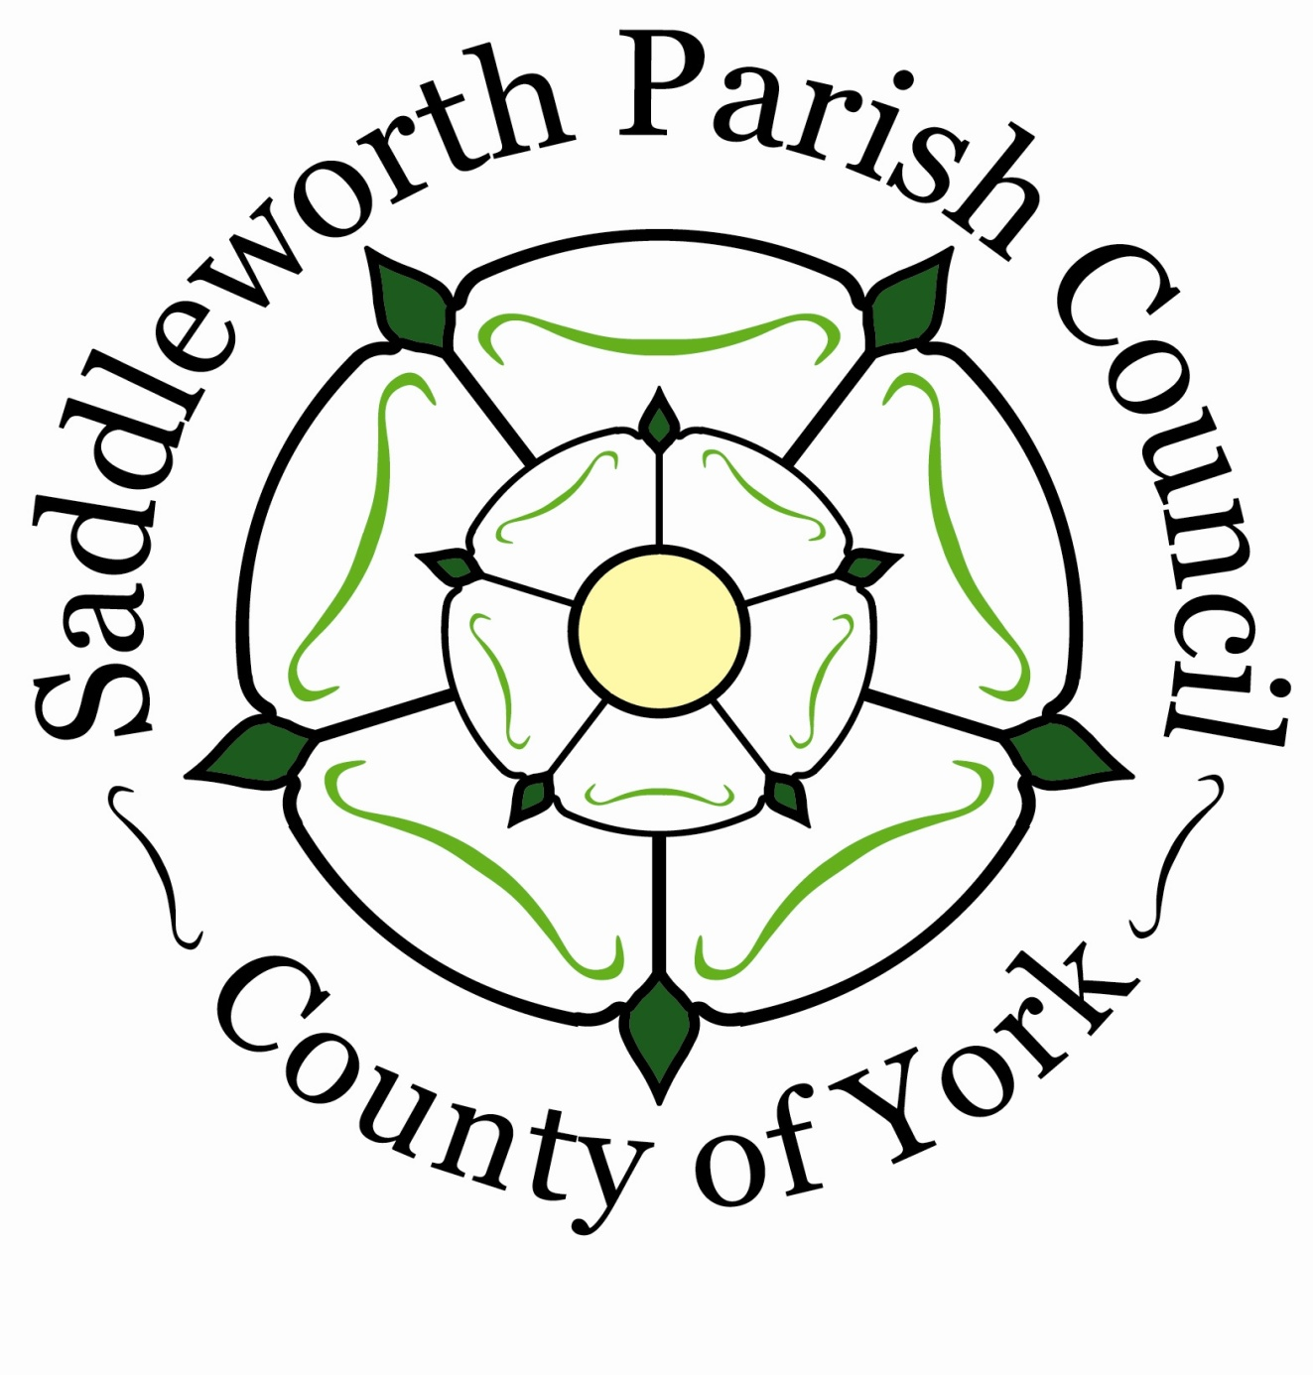
SADDLEWORTH

Parish Council

21^{1st} October 2026
To: All Members of the Saddleworth Parish Council
Dear Sir/Madam
You are hereby summoned to attend the Ordinary Council Meeting of the Parish Council to be held at the Civic Hall on Monday 26th October at 7.30pm for the purpose of conducting the under mentioned business.
Yours faithfully
K E Allott
Clerk to the Council
AGENDA
Welcome by the Chair

- To receive apologies for Absence
- To receive Declarations of Interest
- To Receive Public Questions
- Chair’s Urgent Business
- Update on resurfacing of Smithy Lane and Station Rd, Uppermill (Cllrs Beeley, Blackmore)
- Presentation by RSPB, Kate Hanley
- Presentation by United Utilities, Chris Matthews
- Correspondence
- Response from HM Treasury to Debbie Abrahams, MP regarding our request for a banking hub for Saddleworth
- Update regarding Oldham Council Standards Committee Meeting (Cllr Blackmore)

- To approve and confirm as a correct record the Draft Minutes of the Council Meeting held on 28th September 2026
- To note the minutes of the Traffic & Transport Committee meeting held on 17th September 2026
- To note the minutes of the Strategic Planning Committee Meeting held on 24th September 2026
- To note the minutes of the Finance Committee Meeting held on 24th September 2026
- To note the minutes of the Staffing Committee meeting held on 24th September 2026
- To note the minutes of the Planning Committee Meeting held on 5th October 2026
- To note the minutes of the Communications Committee meeting held on 7th October 2026
- Motion to Council – Celebrating our local heritage
This Council recognises:
the incredible contributions of people from Saddleworth who have contributed to the cultural, social and economic wealth of the area, and far beyond; the work that has already been done to recognise their contributions to the area, both through the Parish Council and others across the community.

This Council particularly notes:
that one of the most prominent contributors to the area’s heritage, Annie Kenney, has a blue plaque at the Leesbrook Mill, in Lees, but that records from her diary show that she was most closely connected with Woodbrook Mill in Springhead;

This Council calls for:
the promotion of further prominent contributors to the area’s heritage to be marked by blue plaques where appropriate, through consultation with the residents of the Parish; the blue plaque at Leesbrook Mill for Annie Kenney, to be re-sited (with all appropriate agreements) to Woodbrook Mill in Springhead;

further recognition of the contribution of the wider Kenney family to the suffragette movement.

Blue plaques in the Parish include ones for:
100 years of the Greenfield Whit Friday contest (King William IV pub, Greenfield); Roger Tanner (Saddleworth Museum, Uppermill); AB Wood (Pick Hill, Uppermill); The Toll-House (17 Chew Valley Road, Greenfield); Lord Rhodes (3 Valley Cottages, Manchester Road, Greenfield); Henry Platt (The Smithy, Bridge House, Dobcross); Bishop Wheeler (Sacred Heart Church, Uppermill).

Proposer: Cllr Sam Al-Hamdani, Seconder: Cllr Alicia Marland

- Civic Hall Solar Power - Business Case. This Council resolves to apply to the Public Work Loans Board for funding to progress the Solar Power Installation
- Accounts for Payment:
September 2026 Income £8090.00 Expenditure £ 51,782.60
- Payments List, see appendix 1
Date of the next meeting: Monday 23rd November 2026 at 7.30pm

